Welcome to our houses

Kate Cares Supported Accommodation

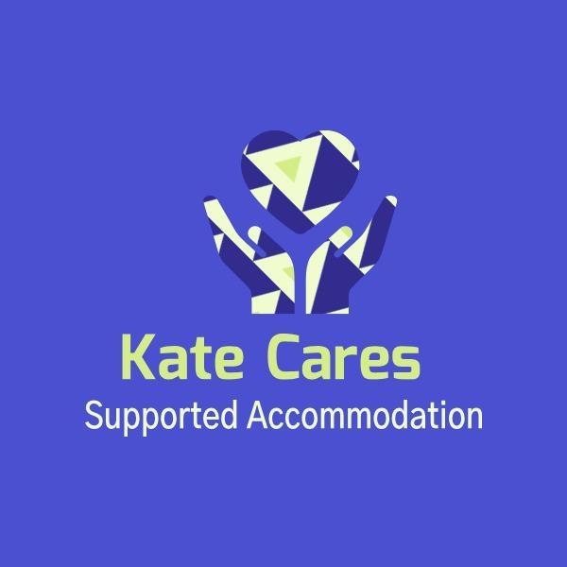

Statement of Purpose

Regulation 9 The Supported Accommodation Regulations 2023

Statement of purpose
(1)—(1) The registered person must compile a statement (“the statement of purpose”)
which covers the following matters in respect of the supported accommodation
undertaking—
(a) its purpose, including its ethos, core aims and function;
(b) the category or categories of supported accommodation it offers;
(c) the services it provides for children it accommodates and supports;
(d) the characteristics of the children for whom it is intended the supported
accommodation undertaking will provide accommodation and support, including
the age range, number and sex of the children;
(e) the facilities it provides to the children it accommodates;
(f) a description of the accommodation it provides, including how the accommodation
meets the accommodation standard (see regulation 6), how the accommodation
might be adapted to meet the individual needs of children it accommodates and
the security arrangements in place;
(g) the address of the registered provider’s principal office, except where this is the
same address as where the children are accommodated;
(h) the organisational structure, including management structure and staffing
arrangements;
(i) how it ensures that the child’s rights and views are at the centre of the support,
service delivery and planning;
(j) the arrangements in place to ensure a child is fully aware of their entitlements
throughout the duration of their placement in supported accommodation;
(k) the positive outcomes the service seeks to achieve for children and its approach
to achieving those outcomes;
(l) the arrangements in place to support the development of children’s independence

About Us

1. Introduction

The supported accommodation at our houses specialises in providing accommodation and support to care experienced children aged 16-23 of either sex.
We plan to accommodate children under the following category:
1. Supported accommodation in a shared or group living situation in premises used to accommodate only looked after children and care leavers. (Regulation 2(1), para (b)) • Shared accommodation. • children have their own bedroom, and may have their own bathroom, and share communal areas (e.g. living room/s, kitchen). • Provision may include foyer-type accommodation that combines support with opportunities for education, training and employment. • This provision may accommodate care leavers aged 18+.
Our primary focus is on enhancing the quality of life for our children, equipping them with positive life skills, and empowering them on their journey to adulthood.
We believe in children and young adults having a really lovely home.
Of equal importance is child safety both in the accommodation such as fire safety and food hygiene and in the community.
Children may have been exploited in the past or been involved in crime in the community and we seek to provide a fresh start and disrupt historical patterns to promote safety.
We are in a generally safe area that provides lots of work and education opportunities from language schools to apprenticeships.
We will work closely with community partners to promote the safety of the children living at our houses , with PCSO visits and fostering strong links with Young Minds Matter and other local services that will help enable children to move towards safe outcomes.
In our commitment to providing high-quality care, we will also work with unaccompanied asylum-seeking children (UASC), ensuring that their unique needs are met with sensitivity and understanding. Our staff are trained to offer tailored support that considers the cultural, emotional, and developmental challenges these children face. We strive to create a safe, nurturing environment where they can feel secure and valued, while also promoting their integration and independence. By working closely with external agencies, we ensure that each child receives comprehensive care, safeguarding their well-being and helping them navigate their new circumstances with confidence
Lennon, Marilyn Chanel and Murphy House offer support and a strong staffing presence in the day and sleep in staff or waking staff available for security/ support purposes every night. We recognise that we are a support service not a care service although we naturally care about our children. We therefore consider children with a history of recent violence towards professionals beyond our remit. We consider children whose emotional dysregulation results in significant property damage as beyond our remit. We consider children who have displayed sexually harmful behaviours as able to be supported only if this is suitable in line with their Pathway Plan and other relevant psychology reports, police interventions and matching with other children. We consider children who have been exploited by gangs or adults as suitable only if this is compatible with any current multi- agency risk assessment and they can be suitably matched with other children living at the home they are placed in, we will also need to be satisfied that the local area is suitable and will not increase their chances of exploitation. We believe children with high emotional needs but strong independence skills are potentially suitable for our service, as we can provide skilled emotional support.
We consider children seeking refuge from family or partner abuse as potentially suitable for our service. We consider children who self harm as suitable but not to the extent that their liberty needs to be deprived or that they need 24/7 1.1 staffing. Due consideration is given to each child as an individual, children who need 24 hour and 1:1 support for a prolonged period of time will need to be reassessed for suitability.

We do want to offer the best level of support and will only employ professional support staff, who are genuine in their desire to help and protect our children and equip them for a bright future. Stringent safer recruitment and ongoing staff training will be in place. All current staff are qualified and experienced in supporting children in residential and support settings such as, supported living, community support or children’s homes.
Together with each child and our partner agencies we will seek to ensure positive outcomes. Positive outcomes are so important and generally a real area of concern for care leavers. We will employ effective support planning, multi-agency communication and direct support so that children can reach for their goals and fulfil their ambitions. We will measure outcomes using evidence based tools and the life skills curriculum.
We recognise our children have experienced trauma which can hinder their self confidence and self esteem, this may also impact on their ability to keep themselves safe and demonstrate prosocial behaviour, we will utilise a trauma- informed approach in our interactions, seeking to collaborate with each child so we can be an ally and cheerleader for our children and break down barriers to their personal success while upholding their rights.
There is a strong focus on safeguarding and the mentors supporting our children will have regular training, testing and guidance regarding safeguarding matters such as dynamic risk assessment, reporting concerns, recognising abuse. The registered manager is a Level 3 Designated Safeguarding Lead. Mentors will collaborate with each child on their safety plans, listen to each child’s views and record their comments and opinions within their plans to accurately reflect their input and wishes.
We will work closely with community partners to ensure an effective contextual approach to safeguarding and helping children make safe decisions for themselves. We will work with local mental health projects and community hubs. We will advocate for children’s entitlements, rights and access to support services for their health, education and future needs, including for transition into adulthood.
We take a positive psychology approach to our support, seeing the potential in our children and moving away from the labels and stereotypes of care experienced people. We want to break down barriers to success for children who leave care and foster their self-confidence and meaningful connections. We seek to empower children and help them feel genuine ownership of their home and community.
Our support sessions are designed to empower children to take control of their quality of life and facilitate opportunities to thrive. Trauma informed trained Mentors collaborate with each child and to measure their progress. Our mentors and leaders have a duty to incorporate each child’s views and wishes into their planning and to make it a joint project between the guiding supporting team and the child themselves.

Our Accommodation
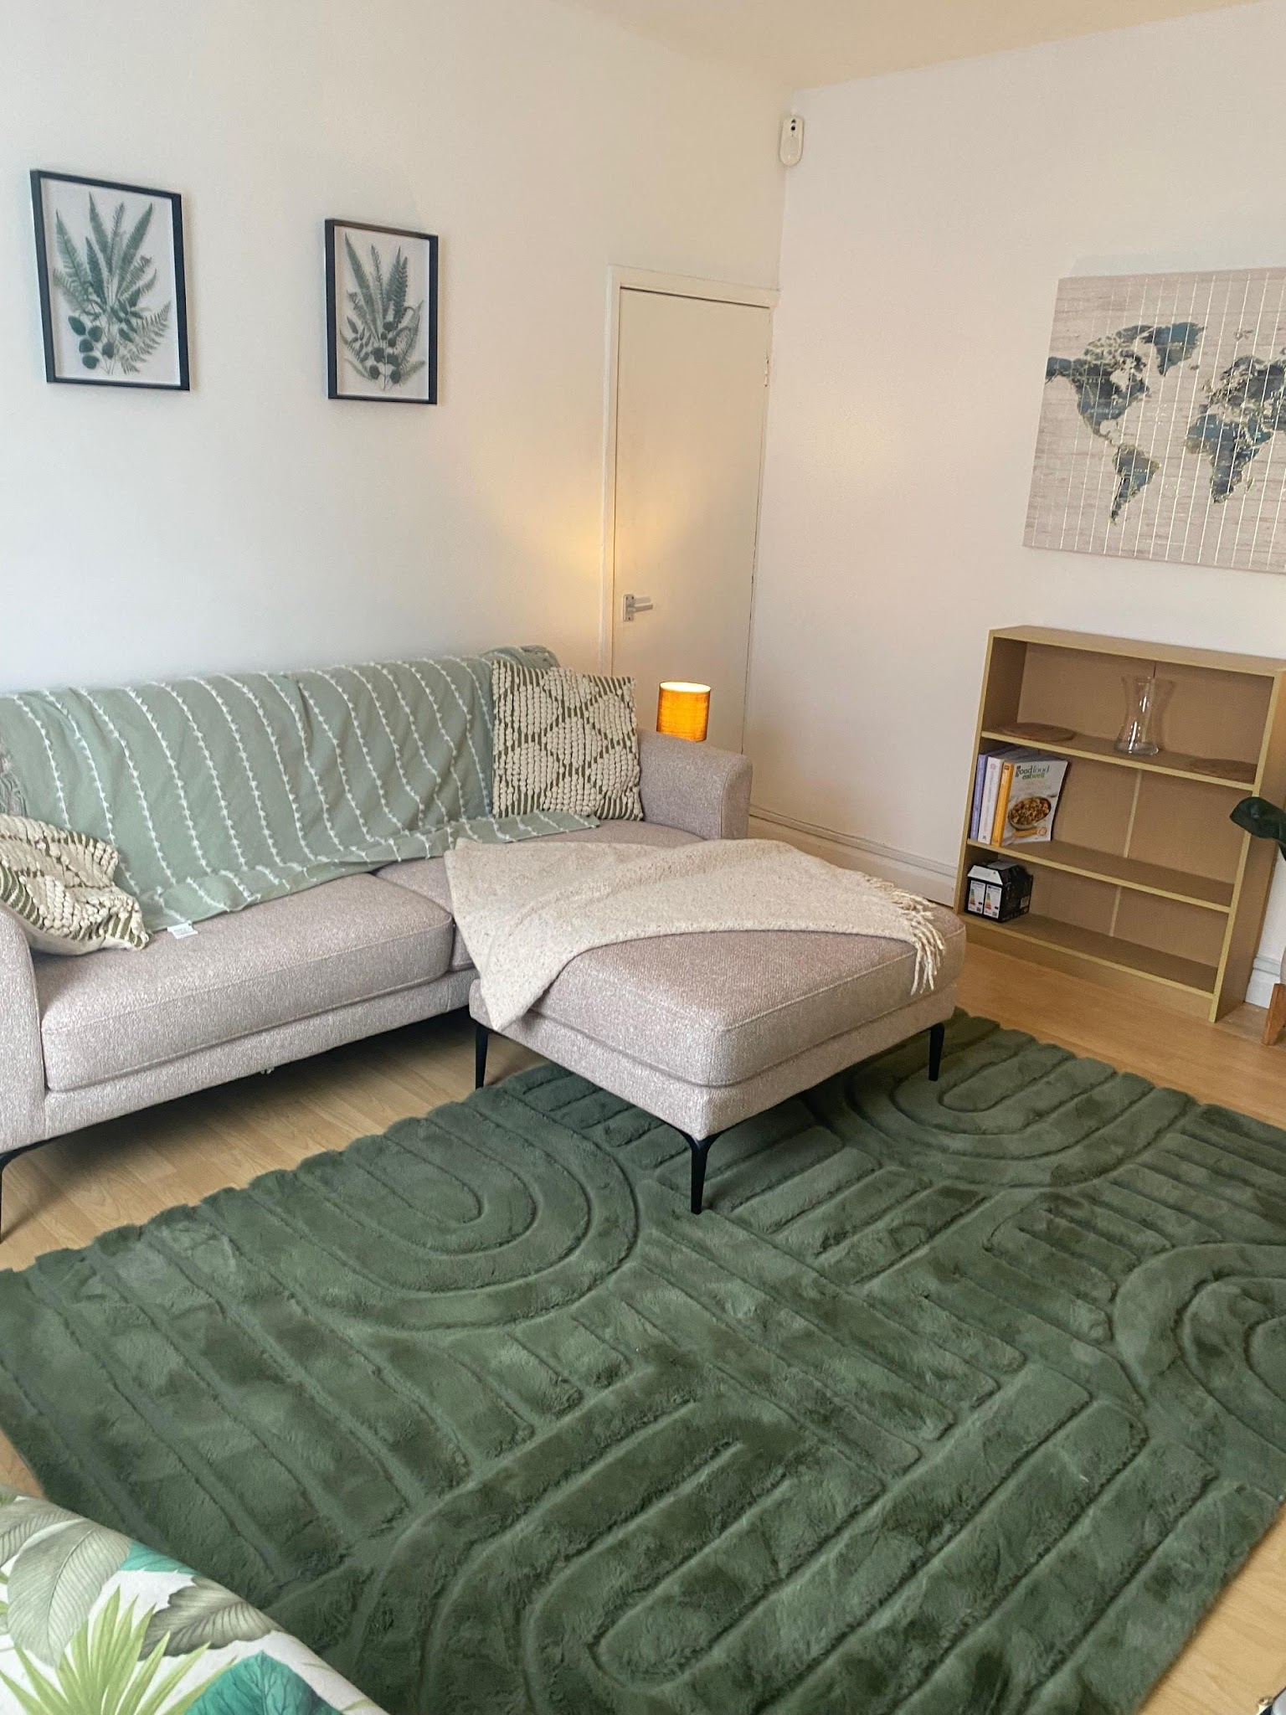

Our supported accommodation is currently based in Gloucester and Cheltenham our homes are named after famous people who are care experienced:

Lennon House - Lennon House is a charming three-bedroom home located on a quiet, historic street in the heart of Cheltenham. It is situated near parks and schools, within a family-friendly community.

The ground floor features a lovely kitchen diner and a convenient downstairs toilet. On the first floor, a spacious lounge offers large, comfortable sofas, a TV, a feature fireplace, and wood floors, with a bright outlook onto the beautiful street.

The second floor comprises three bedrooms and a family bathroom with a shower over the bath. Each bedroom is furnished with a bed, wardrobe, and bedside table, with space for a desk and chair to be chosen by the residents. Upon arrival, children will receive a welcome pack including bedding, towels, personal items, and other requested items, along with soft furnishings and pictures to personalize their rooms.
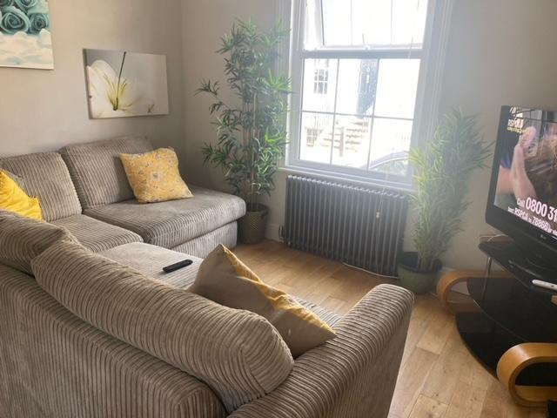

Chanel House is a four-bedroom residence with two bathrooms, a kitchen, a lounge diner, and a spacious garden. Each bedroom is furnished with a double bed, a desk, and ample storage.

Conveniently located near Gloucester city centre, the property offers easy access to local amenities, educational settings, and employment opportunities within a culturally diverse area.
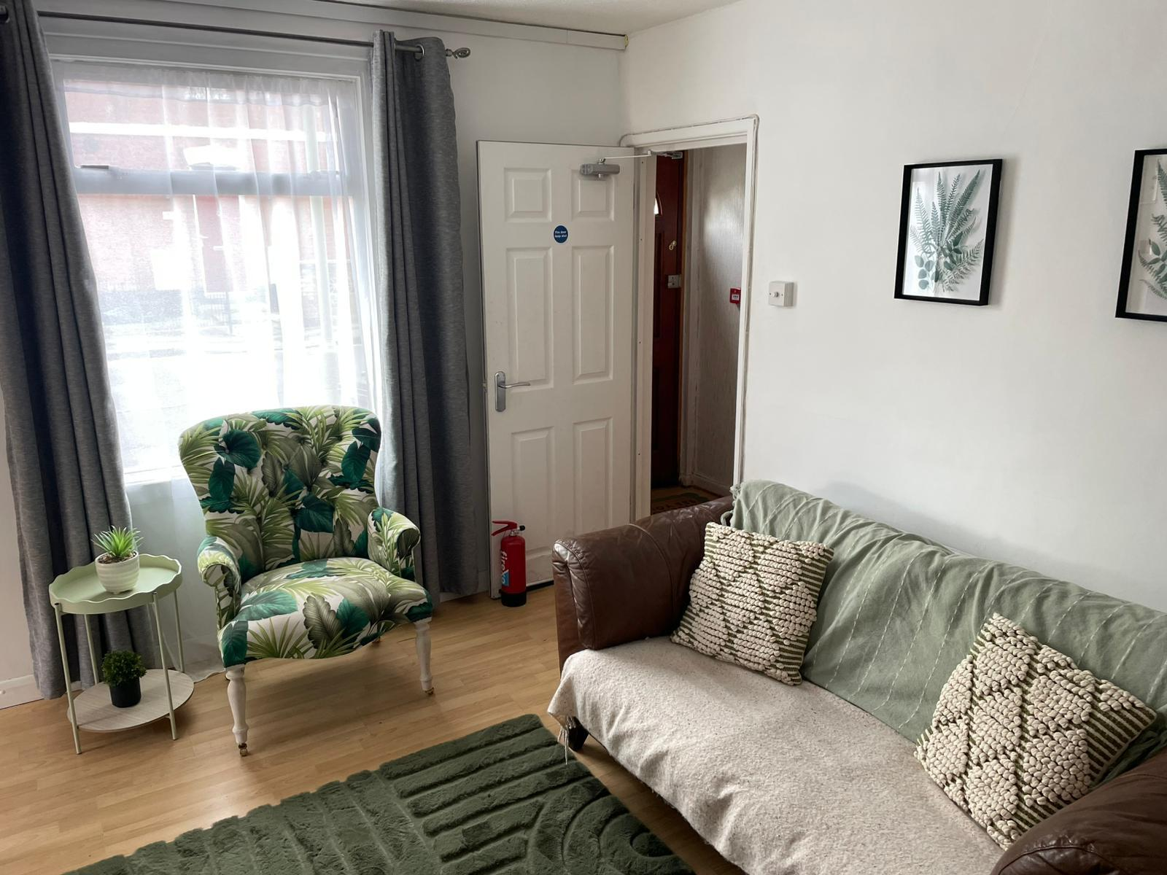

Murphy House is a modern four-bedroom home conveniently located within walking distance of Gloucester town centre and Gloucester Quays. Situated in the culturally diverse Oxford Road area, it offers easy access to all amenities.

The property features a modern fitted kitchen, an open-plan lounge diner, and well-furnished double bedrooms. Each bedroom includes an en-suite bathroom, a double bed, a desk, a wardrobe, and a chest of drawers.

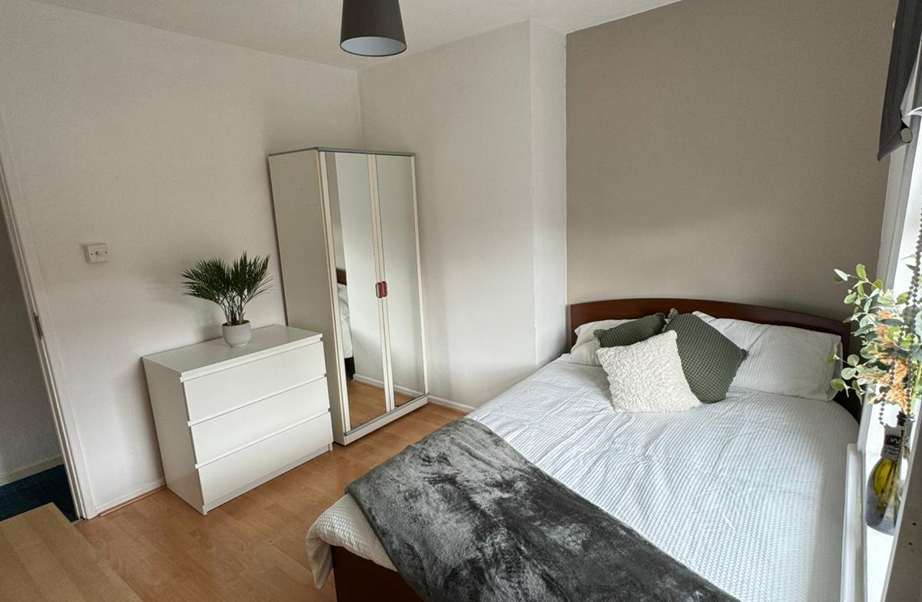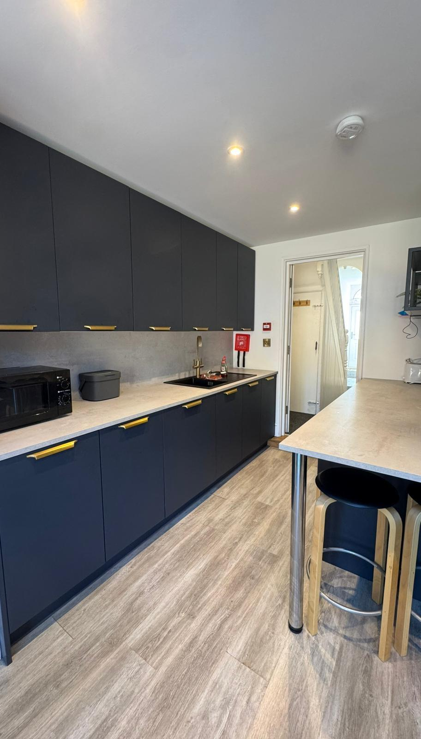
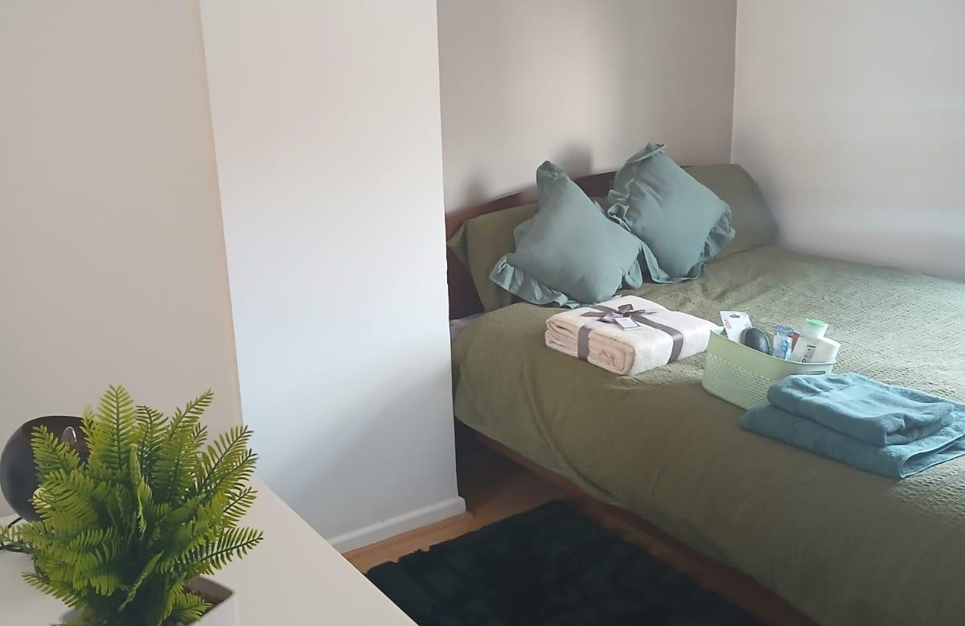

Marilyn House is an 8-bedroom supported accommodation property located in central Gloucester. Its excellent location provides easy walking access to all local amenities, including public transport, education, and health facilities.

The home offers a warm and inviting environment, designed to promote independence and self-sufficiency for young people. It features a large communal kitchen and a snug area. Each room is an en-suite and includes its own private kitchenette and fridge.

Residents benefit from the perfect balance of independence and the necessary support from staff when required.

Bees House
Bees House is an attractive 4-bedroom detached home situated between Gloucester and Cheltenham
The residence features two bedrooms with en-suite facilities, alongside a spacious shared bathroom equipped with a bathtub.
It boasts a contemporary fitted kitchen and a communal space that includes a dining area and a snug. Additionally, there is a separate living room featuring a large, comfortable sofa and a television.

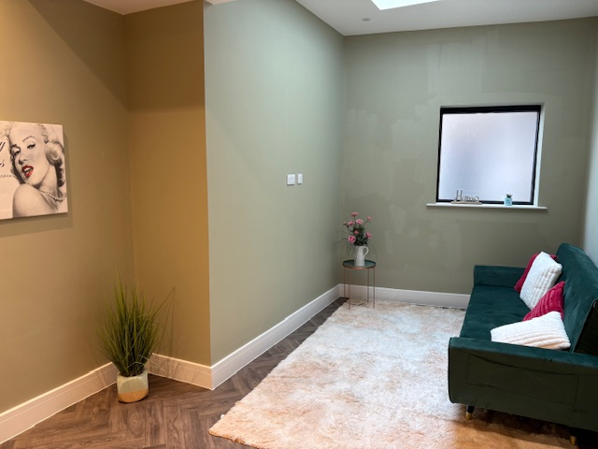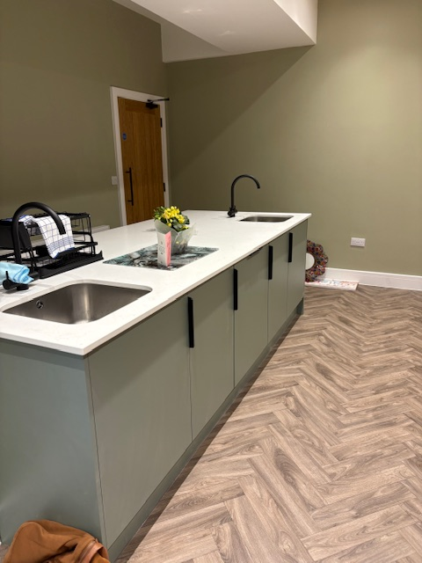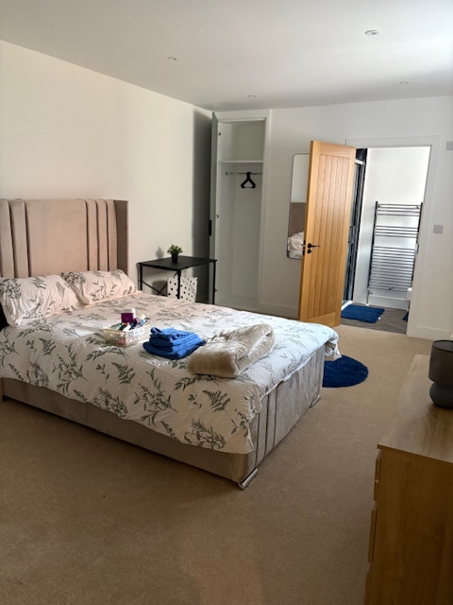

AT KCSA
We provide children with a written agreement, in an individualised accessible format, which outlines their rights, the terms and conditions of the supported accommodation, and how they can raise concerns about the provision. Staffing levels will be designed to meet the individual needs of the children living at our houses. Children will have a key to the front door and a lock on their bedroom door making this accessible only to them and staff for room safety checks.

The location of each home has been carefully considered. Local amenities and job/ education opportunities, leisure places and activities, local risks are all evaluated before a choice of home is made. The registered person reviews the local area risk assessment every six months so we are able to respond to any changes including contextual safeguarding. Local partners are consulted as part of the local area risk assessment including community police, and the local safeguarding partnership. Local authority commissioners are also consulted about the local need and to ascertain best provision match for these needs. Community projects have also been consulted on local opportunities our children can choose to join. The local area for our houses is within walking distance of both urban shopping and leisure centres and local parks. There is a wonderful leisure centre and pool within walking distance. Educational provisions, medical centre’s, dentists, opticians, shops and supermarkets, job opportunities are also all within ten minute walks. There are good transport links to Gloucester, Oxford, Cotswolds, Swindon and further if needed.
There is an environment risk assessment in place for each home and fire safety risk assessment to ensure children are safe at home. Health and safety checks and monitoring are part of the home’s routines. The Mentors will be trained in Food Hygiene and support best practices for the storage and preparation of food. Team Mentors will help children develop their own understanding of safety and how to keep a home hazard free and safely maintained as part of the life skills program.
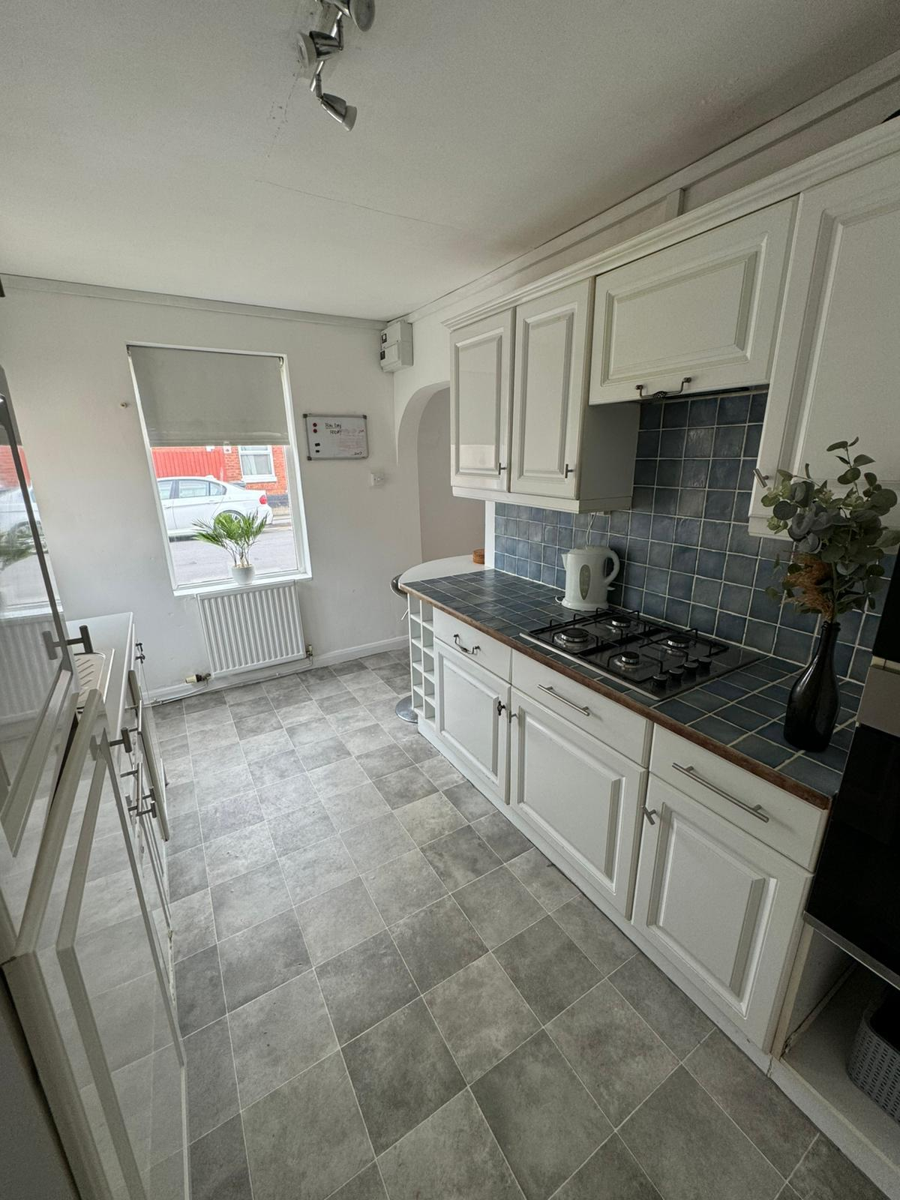

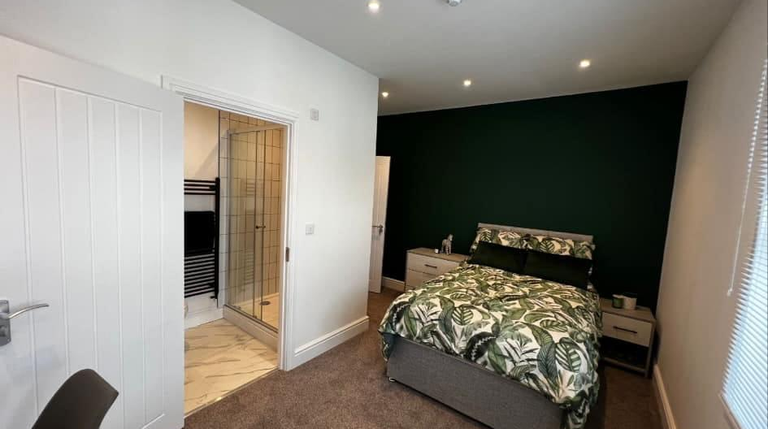

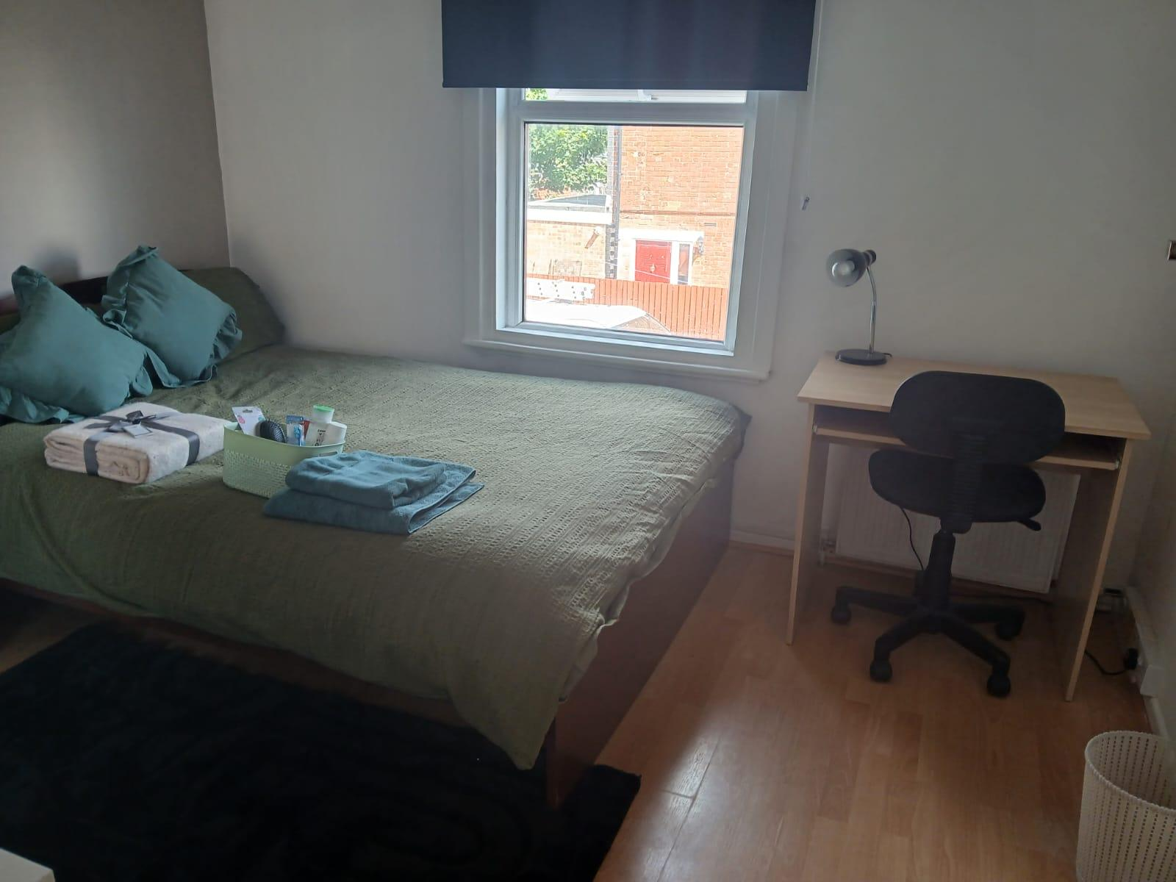

Our Mission Statement and Vision
Mission Statement:
Our mission is to provide safe, quality accommodation and support to children and young adult care leavers so that children can take control of their quality of life. We will foster opportunities to enable each child to make good progress and work towards their plans and goals.
Vision:
We envision a future where our children experience positive outcomes, achieve their goals, and fulfil their ambitions from within a safe and nurturing environment. We are committed to providing lovely accommodation that fosters a sense of belonging and well-being.
Values:
- Advocacy
- Belonging
- Community
- Achievement

Purpose:
To provide a welcoming, safe, home for children to call their own. To facilitate well-being and positive outcomes for our children through effective mentoring. Be a positive player in our community and foster positive connections for children. Provide the right guidance so children can achieve their goals in education and life.

Strategic Goals
- Ensure the well-being and positive outcomes of children on their journey to adulthood
- Use evidence based tools to measure children’s quality of life and progress such as the PERMA model based on Positive Psychology which looks at ways to help foster a good quality of life and is used where a child is happy for this within Mentoring sessions. Alternative tools can be used based on the preferences and capabilities of a child such as the Outcomes Star or the simple use of scales or trauma-informed diagrams or drawings.
- Safe and well maintained homes where children have ownership
- Utilise a bespoke life skills model tailored to each child taking into account their starting point and plans and goals
- Empower children to achieve their educational and employment goals
- Give children new experiences and role model positive relationships
- Be an ally and advocate for our children with other professionals, organisations and government bodies
- Ensure excellent training and development for staff
- Be a positive player in our local community
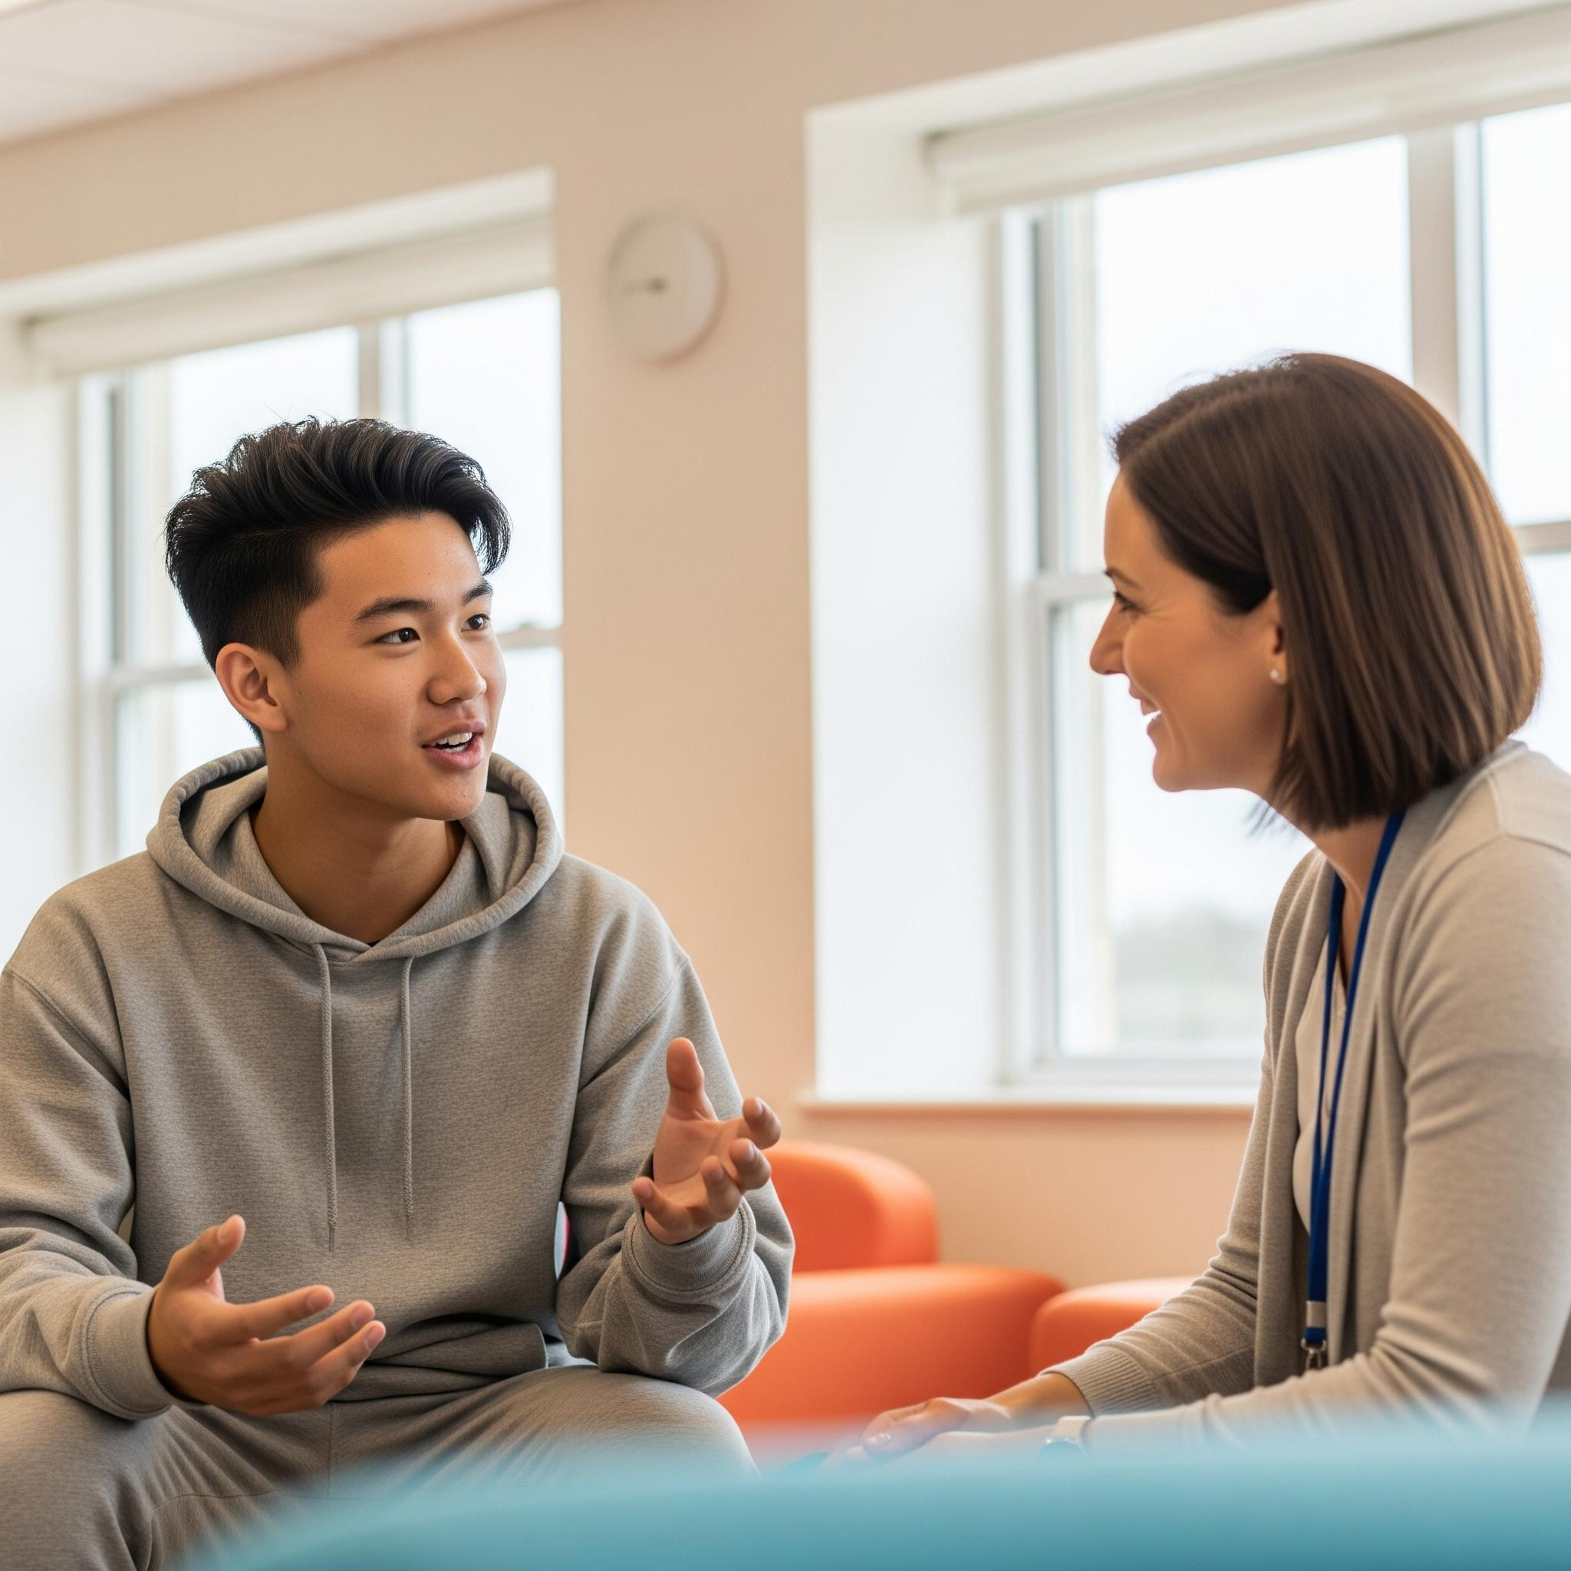
A safe home for a care leaver is a living environment that provides physical, emotional, and psychological security, enabling them to thrive and transition successfully into adulthood. We are committed to offering a stable home built on love:
Physical Safety: The home should be free from physical hazards and risks, ensuring that care leavers are protected from harm or injury. This includes having secure locks on doors and windows, smoke detectors, and meeting building safety codes.
Emotional Support: A safe home provides a nurturing and supportive atmosphere where care leavers feel emotionally secure. This involves support staff who are empathetic, understanding, and available to provide guidance and emotional support when needed.
Stability and Consistency: Consistency in routines, rules, and expectations helps care leavers feel secure and stable in their living environment. Knowing what to expect and having a sense of predictability can reduce anxiety and promote a sense of safety.
Respect and Dignity: Care leavers should be treated with respect and dignity, with their rights and autonomy respected. This includes having privacy when needed, being listened to, and having their opinions and preferences taken into consideration.
Access to Support Services: A safe home should provide access to necessary support services, such as mental health counselling, educational support, healthcare, and vocational training. Having access to these resources ensures that children can address any challenges they may face and receive the assistance they need to succeed.
Positive Relationships: Positive relationships with family, friends, other children, and Mentors are essential for creating a safe and supportive home environment. These relationships provide children with a sense of belonging, attachment, and social support, which are crucial for their well-being and development.
Overall, a safe home for a child goes beyond just physical shelter—it encompasses emotional, psychological, and social aspects that contribute to their overall sense of security, well-being, and ability to thrive as they transition to independent living.

Safeguarding our children is at the heart of what we do. We are dedicated to promoting each child’s welfare. We will act promptly to address any arising safety concerns from contextual safeguarding to online concerns. The registered manager will promote a transparent and effective safeguarding culture. All staff will receive regular safeguarding training. Training for staff will be of a high standard and meet their specific needs to ensure staff are well equipped and confident to support our children keeping them from harm.

We will offer group activities, chosen by the children, from sports to crafts, Bingo or a weekly Carvery. Our children won’t have to be isolated or feel lonely. Children will have opportunities to develop social confidence in an inclusive, accepting environment. We will sign post children to support services and facilitate access to social and community participation.
We will offer transportation to education during transition periods for children and help them attend and achieve within their education provision including meeting and communicating regularly with education providers. Access to education and employment is crucial to help the children we accommodate move towards a positive future and we will evidence our plans to support each child’s educational attendance and success.
Advocacy for children to promote their quality of life and supporting children to raise concerns about their accommodation and or support is a key part of our service. The registered manager will take the lead on supporting complaints in a timely manner and follow our complaints policy effectively.
The manager will measure progress and quality of life for our children each month using our measuring tools and life skills modules. We will create action plans with children and seek to focus on achievement and progress to help children grow in confidence and self -esteem. We will assess how well we are doing to help each child and act accordingly to develop any areas of weakness.

Our Referrals and Admissions
We offer transparent, person-centred support for 16-18 year-olds who are trauma survivors under local authority care or care leavers. Referrals are accepted via portals, email, or phone, adhering to eligibility criteria based on age, vulnerabilities, chronology, past experiences, protected characteristics, risk history, and specific needs, aligning with legislation.

Our assessment team conducts initial assessments within 24 hours, considering individual needs, likes, and preferences, and the child's compatibility with current residents. We encourage visits and involve the child in evaluating our ability to meet their needs. A detailed matching analysis form is completed.

We collaborate with referrers and external agencies, evaluating staff skills against individual needs. Upon admission, individualised support and development plans are created within 48 hours.

A quarterly review, incorporating feedback from children, staff, and referrers, ensures tailored and effective support, upholding legal standards, and promoting a supportive environment.
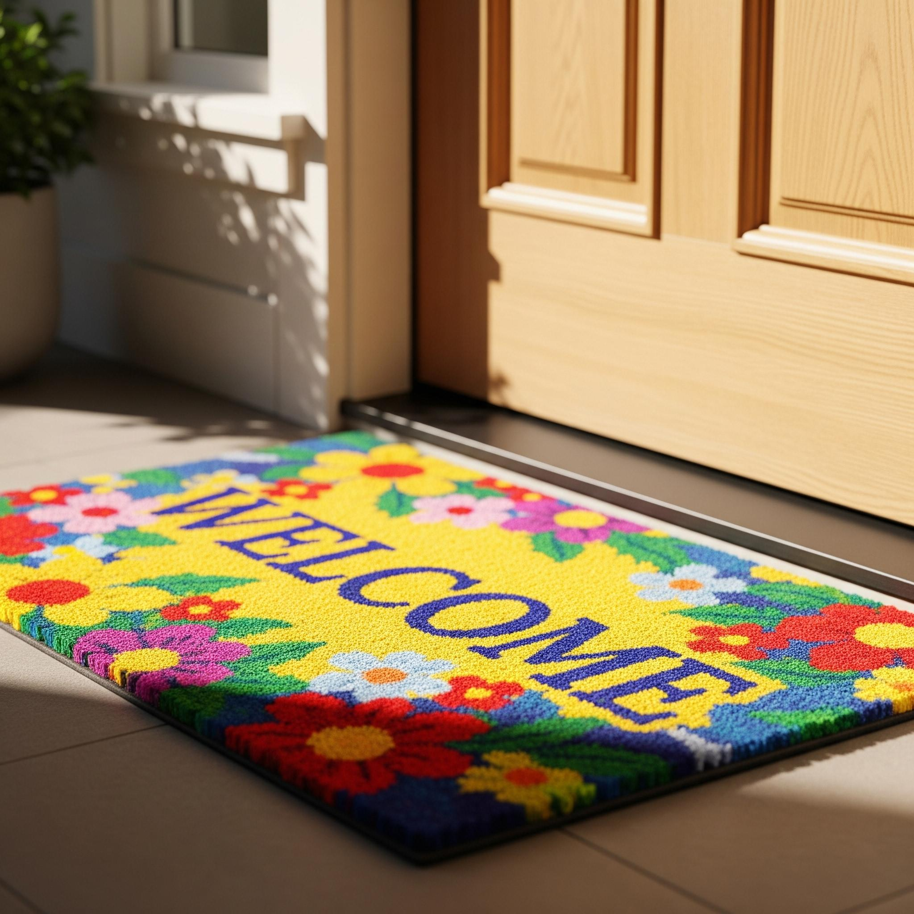

Our Children’s Support Plans
We support children in creating and understanding their Pathway Plans, applying a trauma-informed and holistic approach. Our mission is to help every child thrive, using tailored 'Support and Development Plans' that integrate their Pathway Plan. Our relationship-based approach utilizes trauma research and positive psychology, with the PERMA model guiding our support: Positive Emotions, Engagement, Relationships, Meaning, and Accomplishments. We also offer an independence program with a 'Life skills curriculum' to foster overall well-being. Children actively participate in pathway planning, with their views on health, education, and personal development recorded monthly. We collaborate with external agencies for holistic support and community integration. Monthly monitoring and reviews ensure plans align with evolving needs. Our commitment to empowering children is reflected in accessible documentation and a nurturing environment where every child's voice is valued.



Health and Nutrition
We prioritise the health and nutrition of children in our care. Our individualised Health Plan considers both mental and physical well-being, offering cooking workshops and nutritional education. We assist with medical appointments and support cultural dietary needs.

Children are empowered to manage their own medication after an initial assessment and discussion. We provide mentoring, secure storage, and weekly stock checks by managers or mentors. Staff receive comprehensive training.

We continuously assess and adapt our Health and Nutrition Plan to meet evolving needs. We ensure children are registered with local doctors, dentists, and opticians, checking this monthly. We also facilitate access to other professionals like CAMHS and address EHCP identified needs, attending meetings and communicating with families and professionals.

Equality, identity, culture, rights of children
We provide a nurturing, inclusive environment that supports children's cultural, linguistic, and religious needs.
We foster positive relationships and adhere to legislation including The Supported Accommodation Regulations 2023, The Children Act 1989, The Care Act 2014, United Nations Convention on the Rights of the Child, the Human Rights Act, Working Together to Safeguard Children 2023, and the Prevent Duty.
We cultivate cultural sensitivity and awareness among staff, providing linguistic support and encouraging language development.
We support children in practising their faith by providing spaces for prayer, accommodating dietary restrictions, and organising cultural events, celebrating diversity and strengthening community bonds.



Our staffing and support structure:
The workforce at Kate Cares follows a structured hierarchy to ensure clear lines of accountability and support. The organisational flow is as follows:
Director
↓
Operations Manager
↓
Service Manager
↓
Deputy Manager
↓
Senior Mentors
↓
Mentors / Night Support Staff
The Director/owner
Kate Allen is a Level 5 and Level 3 qualified children’s residential social care manager with over twenty years leadership experience within children’s social care, a degree in Social Sciences and a Postgraduate Diploma in Careers Guidance. Kate is extensively trained and experienced in supporting children who are trauma experienced including trauma informed practice and Dyadic Developmental Psychotherapy. Kate has held Registered Manager, Responsible Individual and senior operational roles for children’s home companies and supported accommodation. Kate is a certified safeguarding trainer with a sound understanding of how to implement positive cultures and quality support services for children. Kate is a member of Dialogue best practice forum and the National Association of Supported Accommodation Partners. Kate is responsible for the companies development and oversight of the Board as Chair.

The service manager Kimberley Poole
Qualified at level 5 in health and social with over 20 years experience in supporting children and young people.
Kim, our manager, will coordinate each placement, communicate with placing authorities, regulators, family and professionals, oversee each child's plans and inspect each home on a weekly basis. They will ensure we are a compliant service always aiming to achieve beyond the standard level of supported accommodation services expected. They will act as safeguarding lead and support a culture of transparency where children and staff can thrive. The registered manager with support from the operations manager will oversee each child’s journey and measure their progress against their own set goals and their relevant plans.

Operations Manager and Nominated Individual
Alena Campbell (Lenny) is a Level 7 Qualified leader in children's social care with over twenty years relevant experience supporting children and families who have experienced trauma. Alena is also Level 5 qualified in leadership in children’s social care. Alena spent several years as a senior residential support worker before moving into leadership within Gloucester County Council and supporting parents with the Solihull Method and managing programs of support. Alena is keen to offer warm and relationship based leadership to the team and be a trusted person advocating for our children. The operations manager will attend relevant meetings and communicate with professionals to case manage each child. They will promote each child’s voice and advocate for their wants and needs. The operations manager will ensure health and safety checks are undertaken at each home on a weekly basis and that there is a program of support sessions for each child to help them be safe and make good progress. The operations manager will be present at each home on a weekly basis and will also take part in group activities and family style meals. The operations manager will check each child is receiving their entitlements and record progress with regards entitlements on their development plans. The operations manager is responsible for the line management of Mentors and running the monthly team meetings.

Sleep in staff are available within our homes overnight either awake or sleep in depending on the home size and are available to the children throughout the night should they need support.
Overnight on-call support is available for children, with a designated, trained staff member responding to needs and calls. At Lennon, Chanel, Marilyn, Bees and Murphy Houses, the on-call manager is alerted to unexpected visitors or children leaving via sleep-in staff or entrance cameras (similar to 'Ring-Go'). Consent for camera use is assumed upon placement and sought in writing from local authorities and guardians. Alternatives will be discussed if authorities object.

Consistent, named Mentors work 1:1 with each child to help them progress, advocate for them, and uphold company values. They teach life skills, including home maintenance, budgeting, self-care, and understanding the world. Mentors report safety concerns, ensure a safe home environment, visit children, facilitate learning and employment, and aid community access. They receive 4-weekly supervision and monthly team meetings for good practice and information sharing, and are supported in ongoing development.

We offer personalised, temporary additional support packages for children transitioning into a new home, based on their individual needs and wishes. These packages, with agreed timelines, aim to improve children's quality of life and felt safety, helping them progress towards independence and reduce the need for high support levels.


Recruitment
We prioritise staff recruitment, ensuring our team is dedicated to children's safety and well-being. We follow stringent checks, including enhanced DBS six monthly checks, Driver and business insurance and references, adhering to Supported Accommodation Regulations 2023 and GDPR. We seek experienced, qualified staff with a genuine ability to mentor vulnerable children, fostering a culture of excellence.

Induction and Training
Staff undergo a six-month induction and training, completing an Induction Booklet and setting professional targets with yearly reviews. Our workforce plan supports our strategic vision.
Mandatory pre-service training includes:
- Safeguarding (abuse signs, response)
- First Aid
- Induction days
- Trauma-Informed Practice
- De-escalation and safe holds
Online courses cover: food hygiene, fire safety, neurodiversity, equal opportunities, CSE, FGM, County Lines, and PREVENT duty. Specialist training is needs-based, determined by children's experiences and needs.

Support Staff Supervision
Regular four-weekly supervision supports staff well-being, safeguarding knowledge, and ability to support children, increasing as needed. Monthly staff meetings include leader-led learning, upskilling, peer learning, PERMA, Trauma-Informed support planning, and reflective practice. Children are invited to provide input.

Complaints
We prioritise transparency and accountability in providing high-quality care. Our robust complaints process, in accordance with Regulation 31, ensures concerns are addressed promptly and effectively, guiding continuous improvement. We ensure impartiality, meticulous record-keeping, and no reprisals for raising concerns. Contact:
Alena@kcsupportedaccom.com
We will respond within seven days.
Our complaints policy is available on request.
See here for the complaints policy:
https://docs.google.com/document/d/19mMe7Z60kOlEqXweK27TarAsFy7RSrrm/edit?usp=sharing&ouid=112225170980546058828&rtpof=true&sd=true
See here for the complaints form:
https://docs.google.com/document/d/1U1PzqhfAi3MaQ3G-1wlLlxErE5AeBzX91vnzQCrglfY/edit?usp=sharing

Upon receiving a complaint, we acknowledge it within seven working days and investigate within 14 working days. An informal resolution may be pursued within 10 working days. Children receive a formal response within 10 working days. Records are maintained, and periodic reviews enhance procedures. Accessible information and staff training foster a consistent, fair approach. This comprehensive approach underscores our dedication to transparency, accountability, and continuous improvement, aligning with Regulation 31.

Behaviour Support and Countering Bullying and Discrimination
Our houses are committed to a safe, supportive, and inclusive environment. Our Behavior Management Policy addresses behaviour support, bullying, discrimination, and integrates a trauma-informed approach. We prioritise reasonable behaviour standards, harm reduction, welfare protection, and safety. Clear expectations and open communication reinforce positive behaviour. Restraint is used only exceptionally, prioritising de-escalation and positive behavioural support. Challenging behaviour receives proportionate responses, involving other authorities when necessary. Meticulous recording and reporting are done within 24 hours. Ongoing staff training and policy review ensure consistent implementation.

Education/ Employment
We believe education empowers young people. Our support helps children achieve their full potential through personalised guidance, academic assistance (homework, study skills), and access to resources. We partner with educational institutions and authorities to ensure children thrive academically and receive their entitlements, including Independent Reviewing Officers, Pathway Plans, and Virtual School Heads. We also support alternative education, language schools, and SEND provision.

Beyond academics, we prioritise holistic development. Our programs integrate life skills, vocational guidance, and career planning. Staff create plans with children, teaching essential life skills and career readiness, equipping them for academic and future success.



Safeguarding and Child Protection
At our houses we consider the safety and well-being of the children to be of paramount importance. Our commitment to safeguarding and child protection is integral to our mission, and we aim to adhere rigorously to all relevant legislation and OFSTED regulations.

1. Leadership and Culture:
- Our leadership team fosters a culture of vigilance and responsibility towards safeguarding.
- Staff members are trained and encouraged to recognize and respond promptly to any signs of abuse or neglect. Knowledge is tested in supervision and team meetings. Role play and scenarios help the team practise and be confident to spot signs of abuse and how to act on them.

2. Policies and Procedures:
- We maintain comprehensive and up-to-date safeguarding policies and procedures, ensuring they align with current legislation including Working together to safeguard children and the Gloucestershire safeguarding partnership guidance and protocols for raising concerns and referrals.
- Regular reviews are conducted to incorporate any changes in statutory guidance or best practices.

3. Training and Awareness:
- All staff undergo thorough safeguarding training at level 1 and 2 during their induction, and regular refresher courses are provided.
- Staff members are kept informed about the latest developments in safeguarding and child protection during team meetings, newsletters and in -house safeguarding practice sessions.
- On call managers are trained as designated safeguarding leads as well as the registered manager

4. Risk Assessment and Management:
- We conduct comprehensive risk assessments, both at individual and environmental levels to identify potential risks to our children.
- Mitigation strategies are implemented promptly, and risks are regularly reviewed.

5. Collaboration and Partnership:
- We work closely with external agencies, including local authorities, health services, and the police, to ensure a coordinated approach to safeguarding.
- Information sharing protocols are in place to facilitate effective collaboration.

6. Child-Centred Approach:
- Children are actively involved in discussions about their safety and well-being.
- We provide accessible information to children about their rights, how to express concerns, and where to seek help and provide relevant contact numbers on the children’s guide.

7. Designated Safeguarding Officer (DSL):
- Our Designated Safeguarding Leads oversee all aspects of safeguarding and child protection; this is the registered manager and on- call managers.
- The DSL ensures that any concerns are handled in accordance with established procedures and regulations. Including missing children incidents, self harm, accidents, contextual safeguarding and radicalisation.

8. Record Keeping:
- Detailed records are maintained for all safeguarding concerns, actions taken, and outcomes recorded.
- Staff members are trained to document incidents accurately and promptly.
- The registered service manager will keep a central safeguarding record including outcomes and any lessons learned.

9. Continuous Improvement:
- We engage in regular audits and evaluations of our safeguarding practices.
- Feedback from staff, children, and external agencies is actively sought to identify areas for improvement.

10. Reporting to OFSTED:
- We understand the reporting requirements set by OFSTED and ensure timely and accurate submissions of all relevant safeguarding and child protection information. Relevant notifications will be completed as quickly as possible.
By implementing these measures, our houses strive to create a safe and nurturing environment where children can flourish. We remain committed to adapting our practices to meet evolving standards and legislation, ensuring the highest level of safeguarding and child protection at all times


Missing from Care Procedures and Protocol
We have established protocols and procedures to address situations where a child is missing from care, ensuring a swift and coordinated response.
Missing from Care Procedures and Protocols
At our houses supported accommodation, our Missing from Care Procedures and Protocols are developed in accordance with best practices outlined by the Gloucestershire safeguarding children partnership. This ensures a comprehensive and locally-informed approach to managing and responding to situations where a child or child is missing from our care.

1. Risk Assessment and Prevention:
- Regular risk assessments are conducted to identify and address factors contributing to missing incidents including local area, contextual safeguarding.
- Personalised plans, influenced by local insights, are implemented to minimise risks to each child.
- We adhere to the Philomena Protocol, integrating its principles into our risk assessment and prevention strategies.

2. Staff Training and Awareness:
- All staff members receive training in line with the Gloucestershire Safeguarding Partnership guidelines to recognise signs of potential missing incidents.
- Training for staff emphasises proactive measures in preventing and responding to missing situations.
- Training also includes the use of the PERMA model to promote positive well-being and reduce the likelihood of individuals going missing.

3. Reporting Procedures:
- Our reporting procedures align with the Gloucestershire safeguarding children partnership's recommendations, ensuring immediate reporting to designated authorities and the police as required by local protocols.

4. Communication Protocols:
- Effective communication channels, in accordance with the Gloucestershire safeguarding children partnership's guidance, are established for prompt response to missing incidents.
- Protocols with external agencies are shaped by local practices and regularly reviewed.

5. Record Keeping:
- Detailed records of missing incidents, incorporating the Gloucestershire safeguarding children partnership's best practices, are maintained, including circumstances, actions taken, and outcomes.

6. Search and Recovery Protocols:
- Specific search and recovery procedures are developed tailoring efforts to individual needs and potential risks for each child and outlined on their missing from care form.
- Collaborative efforts with local authorities align with the Gloucestershire safeguarding children partnership's standards for a coordinated approach.

7. Support for Individuals:
- Support for individuals upon return adheres to local and national guidelines
- Our support focuses on promoting a better quality of life for each child. Mentors undertake direct work with children to help them with reintegrate home following being missing and seek ways to prevent recurrence of the need to go missing. After every missing a review of the child’s development plan will be undertaken with them and measures to support safety put in place in collaboration with the child and the placing authority and other relevant professionals. Mentors will be altered to any incidents for each child and updated on plans of effective support.

8. Learning and Improvement:
- The Gloucestershire safeguarding children partnership's guidance informs our review process for each missing incident, ensuring continuous improvement and alignment with local best practices.
- Insights from the Philomena Protocol are integrated into our improvement strategies.

9. Multi-Agency Collaboration:
- Active collaboration with local authorities, police, and other relevant agencies aligns with the Gloucestershire safeguarding children partnership's recommendations for a coordinated response.
- Joint training exercises and information-sharing agreements reflect local best practices.

10. Reporting to OFSTED:
- Our reporting to OFSTED on missing incidents adheres to both national and local requirements, it is timely and accurate.
Through our adherence to the Gloucestershire safeguarding children partnership's published information on responding to missing persons, commitment to the Philomena Protocol and child centred responses, our houses demonstrate a comprehensive and innovative approach to safeguarding, prevention, and the well-being of the individuals in our care.

This document will be reviewed on a yearly basis to determine its continued accurate reflection of our service to children.
Kate Care Supported Accommodation address 97 Hewlett Road Cheltenham
Email: alena@kcsupportedaccom.com Tel : 07969328831

