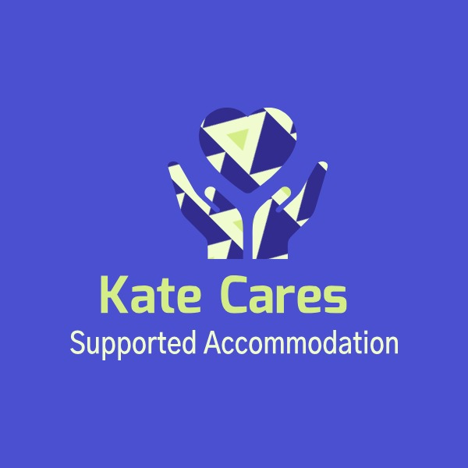

Marilyn House Supported Accommodation
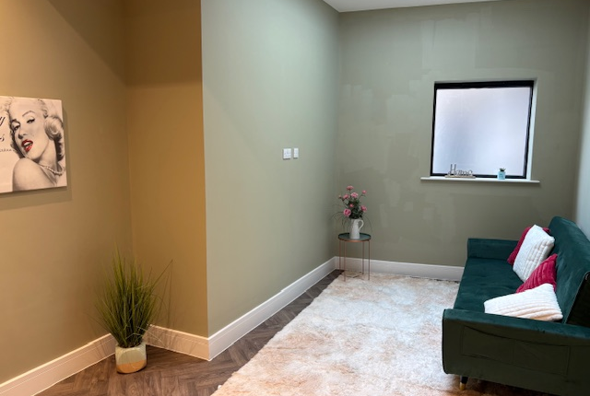

Handbook

Hello, and welcome to Marilyn House  My name is Alyna and I am the Manager of your home. I look after everyone who lives within the home and all the team.  If you have any questions or worries, then please come and talk to me. | We are all really excited that you are coming to live here.  We hope that during your time with us you feel valued, are happy, healthy and safe from harm.  Relationships with children are very important to us and we will always listen to you. | We are really looking forward to meeting you! | 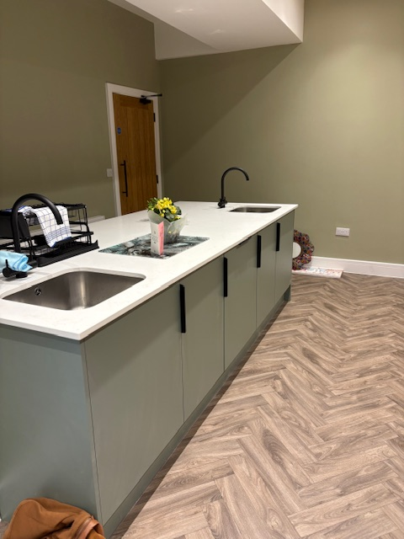

Contents

About Us

Welcome to Marilyn House Supported Accommodation. We provide support and a safe home for you to achieve your dreams.
We aim to:
- Protect your dignity and rights.
- Offer a home that respects your race, culture, religion, and addresses your risks and needs.
- Collaborate with everyone involved in your support.
- Create a supportive environment for your personal growth.
- Provide mentors for advice, life skills, education/work support, and to value your opinions.
Your home will match your individual support needs. This handbook provides essential information about the house and your rights. Please ask if you have questions.
- Looking Out for You: Our priority is your well-being, using the PERMA model to foster positivity.
- Feeling at Home: We strive for safe, comfortable, and welcoming homes where you feel you belong.
- Helping You Thrive: We help you learn life skills, succeed in education/jobs, and understand healthy relationships.
- Being Your Advocate: We support you and work with others to ensure you receive deserved support.
- Supporting Our Team: Our staff receive excellent training to better support you.
- Part of Something Bigger: We aim to be a positive community presence.
- Checking In: We regularly check on your progress and future plans.
Our goal is to ensure you are safe, happy, and prepared for your future.

All of the bedrooms have their own ensuite bathrooms with a shower.
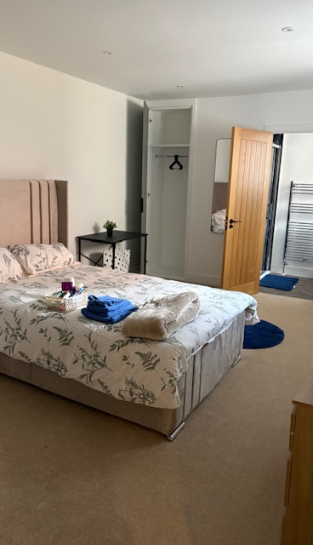
Equal Opportunities

Marilyn House Supported Accommodation is committed to equal opportunity, treating everyone fairly regardless of race, religion, language, culture, sexual orientation, age, or gender. We value diversity and encourage this in our mentors and children. We have policies to support this and will discuss them with you. Please ask any questions; mentors are here to help. This booklet also answers common questions.

Safeguarding and Raising a Complaint

Designated safeguarding lead: Alena Campbell- Nicholas 07969328831 alena@kcsupportedaccom.com

If you feel unsafe or your mentor is unprofessional, report it to a manager or independent professional. We welcome feedback, even complaints, and address them promptly. Speak to your mentor for the complaints procedure and outcome.
Safeguarding complaints are immediately referred to your placing authority. Ask your mentor, manager, social worker, or independent reviewing officer to explain the process. All complaints are recorded and accessible to placing authorities, within confidentiality limits.

You can access the Complaints Policy here: https://docs.google.com/document/d/19mMe7Z60kOlEqXweK27TarAsFy7RSrrm/edit

You will be supported throughout the process and encouraged to discuss your complaint with outside individuals if needed.

You may wish to speak directly to people outside of Marilyn House staff.

Outside organizations you can contact:
- Gloucester Safeguarding Children Partnership: GSCP@gloucestershire.gov.uk, 01452 426565 (Mon-Fri 9am-5pm), Emergency Duty Team (EDT): 01452 614194 (outside hours). You can remain anonymous.
- Childline: 0800 1111 (free, confidential), www.childline.org.uk
- The Citizens Advice Bureau: 0870 126 4026
- Police: 101
- Children's commissioner Rachel De Souza: 08005280731
- Advocate service: NYAS 08088081001 (can help with living arrangements, family contact, leaving care, and support in meetings).
- OFSTED: 03001234666 or enquiries@ofsted.gov.uk
All complaints are confidential and recorded. We provide assistance and support for those with language or communication difficulties.
Moving in Process
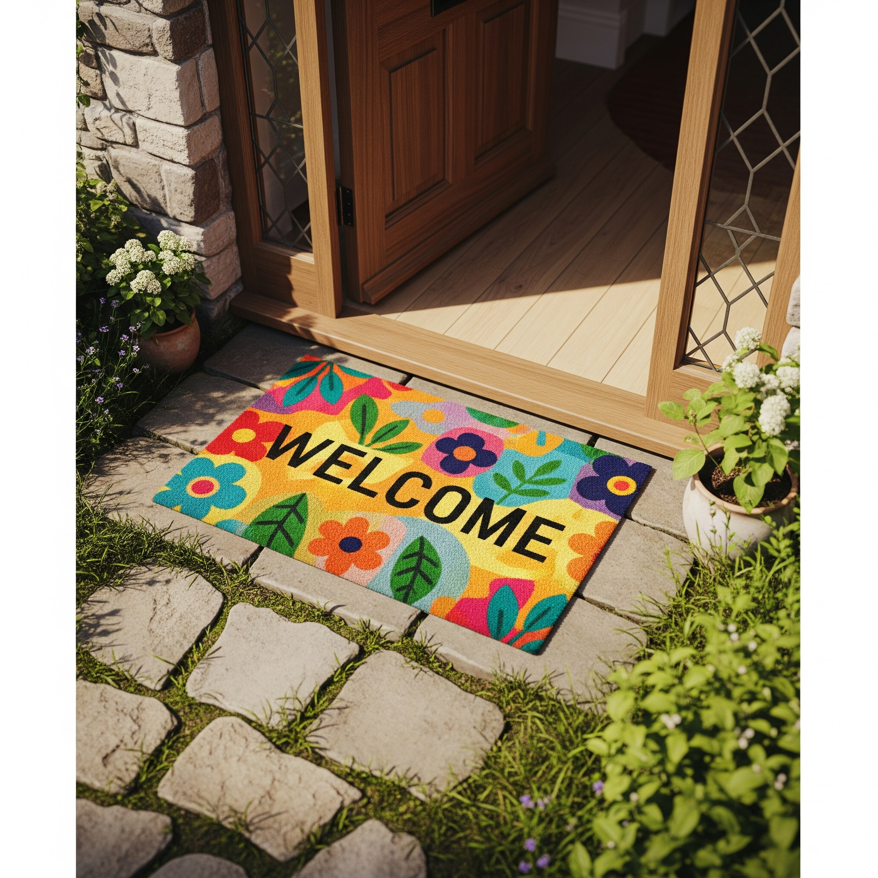
We try to arrange a pre-move-in meeting. On move-in day, you'll receive keys. Your mentor will review provisions, support levels, and appointment scheduling. Our homes are fully furnished, including bedding and kitchen equipment. Shared accommodations have private locked rooms and shared communal areas.

We won't enter your room without notice unless: there's an emergency, we suspect illegal activities (e.g., drugs), we're worried about you, concerned about damage/health and safety, or smoking is detected. For repairs or health/safety checks, we'll try to give a day's notice. If not possible, we'll inform you with a reasonable explanation. Unless you have a good reason to deny access, we will enter.

How long will I stay? This depends on your care/pathway plan. If unhappy, please tell us. We hope you stay long-term and are happy here, possibly beyond 18.


Contact Details
- Alyna@kcsupportedaccom.com
- Head office: 97 Hewlett Road, GL52 6BB
- Director: Kate Allen 07498486388
- Operations Manager: Alena Campbell - Alena@kcsupportedaccom.com
- Mentors: Name - Tel
- On-call Number for Marilyn House: xxxxxx (for help)
- E.D.T. (Emergency Duty Team): EDT@gloucestershire.gov.uk - Tel: 01452 614194
Health:
- Cheltenham 11-25 children's team - 01452426090
- Doctors: https://www.royalwell.co.uk/ (online registration) 120 Swindon Road Tel:08444778962
- Dentist: Mydentist, Eastgate Street, Gloucester. 01452418164
- Optician: Specsavers, Eastgate Street Shopping Centre, 4-6 Bell Walk, Gloucester, GL1 1XH. 01452505163
- CAMHS: Acorn House, Horton Road, Gloucester, GL1 3PX. 03004214899 https://www.ghc.nhs.uk/our-teams-and-services/children-and-young-people/camhs/
Education:
- Prospect Training Service, Waterwells Business Park, Gloucester, GL2 2AL. 01452886888. enquiries@prospecttraining.org
- Gloucester college: https://www.gloscol.ac.uk/ (Offers cutting-edge learning and facilities for university, apprenticeships, or career entry.)
- Gloucestershire University support package for care leavers: Susana Franklyn 01242 714976
Local offer for children care experienced for LA: https://www.gloucestershire.gov.uk/media/uqwjx4bx/care-leavers-offer-brochure-2023-final-march.pdf

Your Support:

Your mentor will meet with you regularly to agree on a support timetable, including evenings and weekends, and provide their contact number. On-call managers may contact you. You will meet all our leaders; no unknown individuals will visit your home.

Our promise to you:
- We will help you.
- We will attend meetings and advocate for you with other professionals, if you wish.
- We will listen to you.
- We will show you how to stay safe at home and in the community.
- You will have a named personal 1:1 Mentor.
- We will convey your views to relevant people like the Virtual School Head.
- We will help you access education, employment, and see family/friends.
- After one year, we will fund ten driving lessons.
- We will help you manage a budget and save for the future.
- We will teach you life skills and spend time doing activities you enjoy.
- We will ask if you feel safe, and if not, we will prioritize your safety and inform your corporate parent/guardian, always being transparent.
In an Emergency (life or death): Call 999. For assistance/advice: 101.

Fire safety: Follow the evacuation plan, raise the alarm, go to the assembly point, and call the on-call manager. Participate in fire drills.

Development Plan and Reviews

Marilyn House Supported Accommodation focuses on preparing you for independent living and improving your well-being and self-determination using positive psychology.


What we expect from you
Breaching the Licence Agreement (e.g., missing support, smoking, drug use) can lead to warnings, eviction, and impact future accommodation.
- Prohibited items/actions: offensive/harmful items, illegal drugs/alcohol, gas canisters, lighter fuel, solvents, stolen goods, property damage, theft, resident romantic/sexual relationships, abusive language/behaviour.
- Violations may result in police involvement/charges.
- Inform us if staying out overnight to avoid being reported missing.
- Lost keys incur a fee; contact your mentor for entry.
- Visitors: One at a time, follow rules, your responsibility.
- Overnight stays (max 2 nights/week) need mentor/social worker permission.
- Do not leave visitors unsupervised or give them keys.
- Under-16s generally not allowed unless family accompanied by parents.
- Day visitors leave by 9 pm.
- Curfew: 11 pm, unless pre-arranged.

- Non-compliance may lead to a behaviour contract or police involvement.
- No illegal substances, stolen goods, or alcohol.
- Police may search for suspected illegal activity.
- Violence towards anyone is not tolerated and may result in losing your home.
- Keep noise levels down.
- If bothered, contact your mentor.
- No indoor smoking/vaping.
- Communal areas (kitchen/dining, downstairs toilet, living room, bathroom) must be kept clean and tidy.
- You are responsible for maintaining appliances/crockery; damage incurs replacement costs.
- Report repairs/emergencies (electric, gas, water, security) to your mentor, or Alyna if unavailable.
- Marilyn House has a TV license; smart TVs are in rooms.
- Activities are resident-interest based, celebrating special occasions. We facilitate group/individual activities with mentor support if funded.
- No 18-rated games/videos.
- Wi-Fi is provided in bedrooms and communal areas.
- Ensure legal, age-appropriate online activity. Do not download illegal music/videos. Misusing social media or bullying will lead to internet restrictions.
- We keep confidential records (meetings, support, complaints, incidents, external info). You can view your file with 48 hours' notice; external agency info requires their permission.
- Information is shared only with consent or for Safeguarding.
- You can also write your own records.
- We support you with life skills, cooking, home management, relationships, and work/education/employment.
- We provide individual/group advice/sessions on safe sex/sexuality (in-house/other agencies) for safety, infection prevention, and avoiding unplanned pregnancies. Mentors have leaflets in the office/on the notice board.
- We help you access contraception/guidance.



Radicalisation
We support Prevent strategies, protecting children from exploitation by terrorists/extremism, similar to safeguarding from drugs, gangs, and alcohol. We monitor for indicators of vulnerability/risk and share information accordingly.

CSE
Child Sexual Exploitation (CSE) is when a person under 18 is sexually exploited by one or more people targeting their youth/inexperience for power. This often involves "grooming" (e.g., receiving gifts/attention) before/during sexual activities. CSE can occur via technology (e.g., coerced image sharing) and often involves actual or threatened violence (to you, friends, family) to prevent disclosure. Report any risk immediately to a mentor.

Bullying
Bullying (whispering, staring, name-calling, hitting, etc.) is unacceptable. Prevention is key. Leaders, mentors, and children must work together to create a positive environment. We strive to minimise/stop bullying by mentors observing and acting, supporting victims, and helping bullies understand/change behaviour. Children are empowered to discuss issues. Mentors address bullying via conversation, educational material, or sanction.

Health and Safety
We ensure a comfortable, well-maintained home. All children should be proud to bring friends/family. Look after furniture/equipment; report damage to mentors. Participate in household chores for cleanliness. Rooms and the house have regular health and safety checks. Smoking indoors is prohibited due to fire risk and illegality. No candles or incense are allowed in rooms due to fire risk. Be careful with abrasive cleaning materials; store them in hard-to-reach cupboards.

Fire Safety
Regular fire drills (anytime) are mandatory. Detailed instructions are in the health and safety cupboard; mentors review monthly. On your first day, your mentor will show you the fire assembly point and procedure. We continually educate you on fire prevention and what to do in a fire.

First aid box
All mentors are basic first aid trained. Children are advised on basic first aid and encouraged to self-care. A readily available first aid box (in the kitchen of every home) is in line with regulations. Use first aid equipment freely for injuries; inform the on-call manager to ensure you're okay and for stock replenishment. Mentors treating broken skin will wear gloves to prevent infection. For serious injuries, seek help or call 999 for an ambulance.

Medical Info

Medication
All medication entering the home must be recorded by your mentor upon arrival or prescription. They will advise on safe administration. You can self-administer unless unsafe. All medication must be locked in your storage cabinet. If you need medication help, it will be added to your development plan (storage, safe administration). You must sign to witness medication intake. If staff administer medication, a risk assessment is needed explaining the intervention and steps to enable self-administration where possible.

If you feel unwell
Inform your mentor immediately if you feel ill, explaining symptoms and duration. Disclose any medication taken. We can help you make a doctor's appointment or advise next steps. For emergencies, call 999 or 111 for advice.

Tell us what you think
Your rights: See your entitlements from children's services: https://www.gloucestershire.gov.uk/media/uqwjx4bx/care-leavers-offer-brochure-2023-final-march.pdf

Have your say
Get involved in your home via direct talks with mentors, anonymous ideas box suggestions, home meetings, complaints/compliments, improvement suggestions, interviewing new mentors, or joining a children's committee. Ask for details.
Email suggestions to alyna@kcsupportedaccom.com or call/text 07840044556
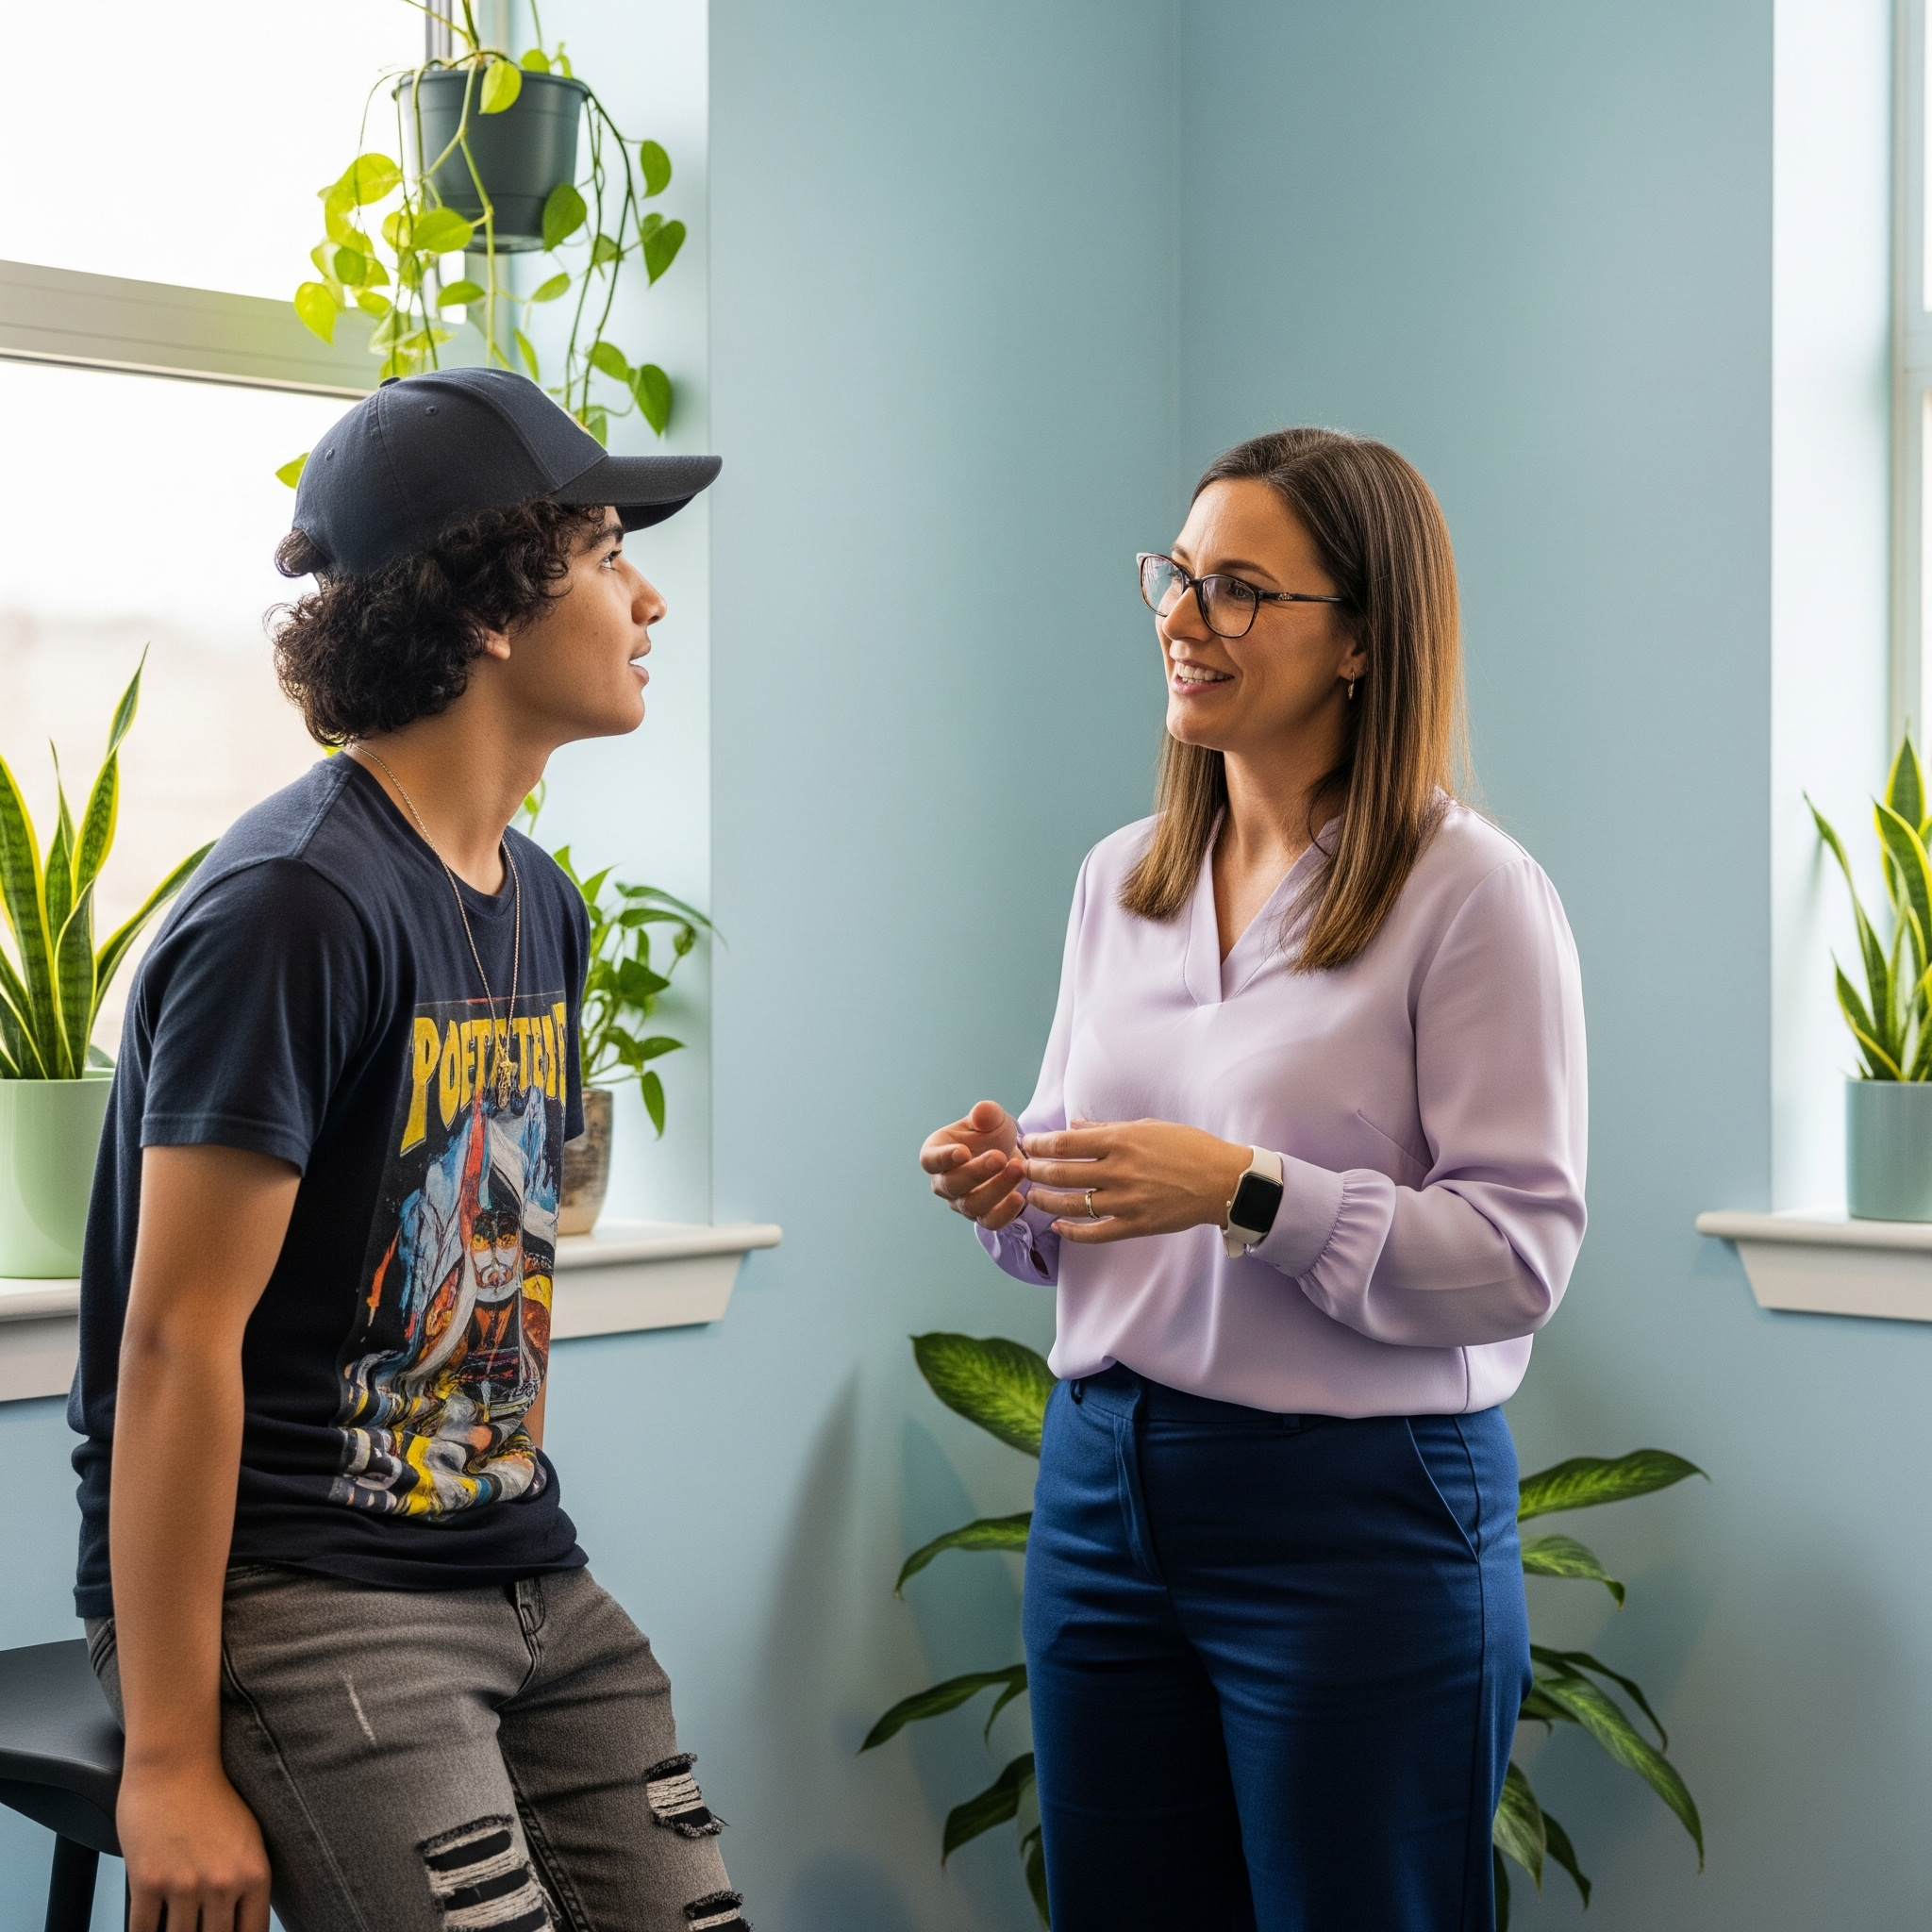
Advocacy
An advocate is an independent person who speaks for you, sharing only what you permit (unless safety is a concern). They've helped others with family contact, home changes, worries, education opportunities, and getting laptops/bikes. Contact National Youth Advocacy Service: 08088081001 or https://www.nyas.net/contact-us/. Your mentor and leaders advocate for you, expressing your views to other professionals and pushing for your needs. We encourage you to lead and prepare you to speak confidently. We also "signpost" (direct you to relevant groups/help) for easier access to entitlements and a better future.

Meetings
Children are encouraged to create agendas and chair reviews/meetings to ensure their views are heard. We provide feedback from meetings we attend on your behalf if you're absent.

Moving out
Planning is crucial for successful transition. We support you with move-on accommodation options and application requirements. Significant persons (you, placing authority, parents/guardian) can be involved. Successful independence requires stability, continuity, positive self-image/esteem, strong support, positive education/training, identity, and good preparation. We aim to provide this.

Your home is always open for safe future visits and organised activities for previous residents.

Declaration
I have read and understood the Children’s Guide and agree to abide by this.
Name:……...…………………………………………………..(Please Print) Signed:…………………………………………………..……..Date:…………………………… ……. (Copy to be retained for your records.)

